PDF EXTRACTOR
EXTRACTING ANSWER FROM PDF BASED ON QUESTION ASKED

TEAM MEMBERS
DEEPAK S
HARISH M
MOHAMMAD ZUHAIR
TUSHAR MOHANTY
SAI SUNDAR S

INTRODUCTION
With information increasingly locked inside PDFs—research papers, contracts, manuals, and reports—finding precise answers quickly is a growing challenge. This project, PDF-QA, builds an end-to-end system that lets users query any PDF in natural language and receive accurate, explainable answers. It combines robust PDF parsing, semantic search using vector embeddings, and powerful language models to return both the exact supporting text and a concise synthesized response.
The system ingests a PDF, extracts and cleans the text while preserving page references, divides the content into semantically meaningful chunks, and indexes those chunks in a vector store. When a user asks a question, the system converts the question into an embedding, retrieves the most relevant passages, and uses a language model to synthesize an answer with citations to the original pages. This approach reduces the time needed to locate information inside long documents, improves comprehension by providing context, and maintains traceability to source material.
The project emphasizes practicality and safety: it uses tried-and-tested Python libraries for extraction (e.g., PyMuPDF or pdfplumber), secure management of API keys for embeddings/LLMs, and includes evaluation metrics (accuracy, latency) and explainability (source snippets and page numbers). Target users include researchers, legal and compliance teams, students, and any knowledge worker who needs fast, reliable answers from document archives.

PROJECT OVERVIEW
The PDF Question-Answering System (PDF-QA) is a Python-based application designed to automatically extract information from PDF documents and generate accurate answers to user queries. It integrates PDF processing libraries with powerful language model APIs to understand the document’s content, retrieve relevant text sections, and produce reliable, context-aware responses.
The system works by first extracting text from the provided PDF, cleaning and organizing it into meaningful chunks, and then converting those chunks into vector embeddings using an API-based embedding model. These embeddings are stored in a vector database to enable efficient semantic search. When a user submits a question, the system converts the question into an embedding, retrieves the most similar document segments, and sends them to a language model to generate a precise answer with supporting references.
This project eliminates the need for manual scanning or reading long documents. It is especially useful for students, researchers, businesses, and analysts who frequently work with large or complex PDFs and require quick access to specific information. With secure API key handling, modular architecture, and scalable components, the system can be integrated into web applications, chatbots, knowledge retrieval tools, and enterprise workflows.

PROBLEM STATEMENT
PDF documents are widely used for sharing information across academic, corporate, and technical environments. However, retrieving specific information from lengthy PDFs—such as research papers, reports, manuals, and legal documents—remains a slow and inefficient process. Users often have to manually read through dozens of pages or use basic keyword search, which fails when the phrasing in the PDF does not match the user’s query or when the required information is spread across multiple sections.
Traditional search methods do not understand context, semantics, or the meaning behind the user’s question. As a result, users struggle to quickly locate accurate answers, leading to lost time, reduced productivity, and difficulty in understanding complex documents.
Therefore, there is a need for an intelligent system that can automatically analyze the content of a PDF and answer user queries in natural language with high accuracy. The system should be capable of extracting text, understanding semantic relationships, retrieving the most relevant information, and generating concise, human-like answers using AI models. It must also handle API keys securely, ensure scalability, and provide explainable results with source references.
This project aims to solve these limitations by building a robust PDF Question-Answering system that combines Python libraries, vector embeddings, and language model APIs to deliver fast, accurate, and context-aware answers from any given PDF.

OBJECTIVE
The primary objectives of the PDF Question-Answering System are:
- To develop an automated system that can extract text from any given PDF using reliable Python libraries while preserving structure, page numbers, and readability.
- To preprocess and organize the extracted content by cleaning, formatting, and dividing it into meaningful text chunks suitable for semantic search.
- To generate vector embeddings of the document content using API-based embedding models to enable efficient and accurate similarity matching.
- To build a scalable vector database that can store and retrieve relevant document segments based on user queries.
- To design a robust question-answering pipeline that retrieves the most relevant text chunks and uses a language model API to produce accurate, context-aware answers.
- To provide explainable answers by including references such as page numbers or text snippets from the original PDF.
- To ensure secure handling of API keys through environment variables and best practices, avoiding exposure or misuse.
- To deliver a user-friendly interface (CLI, API, or web UI) that allows users to upload PDFs and ask questions easily.
- To optimize performance in terms of accuracy, speed, and reliability, suitable for real-world applications like research, business analysis, and documentation review.
- To create a modular and extensible architecture that can be integrated with other applications such as chatbots, enterprise knowledge systems, or study tools.

EXISTING SYSTEM
In the current scenario, most users rely on manual reading or basic keyword search to extract information from PDF documents. Traditional PDF viewers provide only simple search features that match exact words or phrases, which is ineffective when:
- The document uses different terminology than the user’s query
- Information is scattered across multiple pages
- The user needs a summarized or interpreted answer
- The document is long, technical, or complex
Some advanced tools exist for document search, but they have limitations:

1. Manual Reading
Users must read through entire documents to find answers, which is time-consuming, especially for large PDFs like research papers, reports, or legal files.
2. Keyword-Based Search
PDF readers like Adobe Reader support keyword search, but:
- They do not understand meaning or context
- They cannot retrieve answers if the keyword does not appear
- They do not summarize or explain information
- They return multiple irrelevant matches
3. Traditional OCR/Extraction Tools
OCR tools can extract text from scanned PDFs, but:
- They only convert images to text
- They do not perform intelligent question answering
- They lack semantic understanding or reasoning
4. Lack of AI-Driven Contextual Search
Most existing systems cannot:
- Understand natural language questions
- Provide accurate, context-based answers
- Link answers with relevant document sections
- Process the entire document as knowledge
Summary of Limitations
- Time-consuming manual process
- No semantic understanding
- No automated answering capability
- Poor accuracy when keywords differ
- No reference or citation support

PROPOSED SYSTEM
The proposed system introduces an AI-powered solution capable of automatically extracting information from PDF documents and generating accurate, context-aware answers to user queries. Instead of relying on traditional keyword search, the system uses Python libraries such as PyMuPDF or pdfplumber to extract text from PDFs while preserving structure and page references. The extracted text is then cleaned, organized, and divided into meaningful chunks that can be easily processed. Each chunk is converted into a semantic vector embedding using an API-based embedding model, allowing the system to understand the meaning and context of the content rather than just matching keywords. These embeddings are stored in a vector database, enabling fast and efficient retrieval of relevant portions whenever a user asks a question. When a query is entered, the system converts it into an embedding, retrieves the top-matching text sections from the database, and passes them to a language model API to generate a clear and accurate answer. The final output not only includes the answer but also references to the original page or text snippet for transparency. The system securely handles API keys using environment variables and is designed to be user-friendly through either a CLI, web interface, or chatbot-style interaction. Overall, the proposed system provides an intelligent, efficient, and highly scalable approach to extracting meaningful information from large and complex PDF documents.

ARCHITECTURE DESIGN
The architecture of the PDF Question-Answering system is built as a modular, scalable pipeline that moves from document ingestion to answer delivery while keeping traceability, performance, and security in focus. Below I describe the components, their responsibilities, and the data flow between them — followed by an ASCII diagram to visualise the pipeline.
Components & Responsibilities
1. Client / UI Layer
Users interact via a web UI (Streamlit/React), CLI, or API client. This layer handles file upload, question input, and displays answers with source citations and metadata. It communicates with the backend over REST or WebSocket.
2. API / Orchestration Layer
A FastAPI (or Flask) service receives user requests and orchestrates the pipeline. It validates inputs, enforces rate limits, authenticates users, and forwards jobs to the processing pipeline. It also exposes endpoints for status and metrics.
3. Ingestion & Extraction Service
When a PDF is uploaded, this service extracts text and metadata. It uses a combination of PDF parsers (PyMuPDF / pdfplumber / pdfminer.six) and OCR (Tesseract) for scanned pages. The output is cleaned plain text segmented by page and position, plus optional structural hints (headings, tables).
4. Preprocessing & Chunking
Extracted text is normalized (whitespace, headers/footers removal, de-dup), language detected, and split into overlapping, semantically coherent chunks. Each chunk carries metadata: document id, page number(s), character offsets, and section labels.
5. Embedding Generator
This module batches chunks and calls the embedding API (or local model) to convert text chunks to vector embeddings. It handles batching, rate-limit/backoff, and caching of embeddings for re-uploads or repeated documents.
6. Vector Store / Index
Embeddings and chunk metadata are stored in a vector database (FAISS, Chroma, Milvus). The index supports nearest-neighbour lookups, stored metadata retrieval, and incremental updates (add/remove vectors).
7. Retriever & Reranker
On a query, the retriever embeds the user question, queries the vector store for top-K nearest chunks, and optionally applies a lightweight reranker (cross-encoder or heuristic ranking) to reorder results for quality.
8. Context Assembler
Selected chunks are assembled into a context window for the LLM. This component formats the retrieved snippets, prunes or compresses content to fit token limits, and adds citation metadata (page numbers, offsets).
9. LLM / Generation Layer
The orchestrator calls an LLM API with a structured prompt (system + user + retrieved context). The model returns a synthesized answer, plus an explicit list of supporting snippets or “I don’t know” when evidence is insufficient. Optionally, an extractive answer flow can be run in parallel to supply exact spans.
10. Postprocessing & Explainability
Answers are postprocessed to ensure safety (remove hallucinations, sanitize), attach citations, compute confidence scores (similarity + LLM token cues), and prepare the final payload for the client.
11. Storage, Logging & Monitoring
Document metadata, indexes, query logs (no secrets), usage metrics, and evaluation logs are persisted for audit, debugging, and continuous evaluation. Monitoring/alerts (Prometheus/Grafana) track latency, error rates, and API usage.
12. Security & Key Management
API keys live in environment variables or secret managers (AWS Secrets Manager / Vault). The system enforces least privilege, encrypts data at rest and in transit, and supports optional document retention policies and redaction for sensitive docs.
13. Optional Components
- Cache layer for recurring queries (Redis).
- Batch processing worker (Celery/RQ) for heavy extraction/embedding jobs.
- Admin UI for index management and manual re-indexing.
- Evaluation module that runs benchmarks (EM, F1, human eval) to measure QA quality.
Data Flow (high level)
- User uploads PDF → API receives file.
- API forwards to Ingestion Service → extract text + metadata.
- Preprocessing/Chunking creates chunks with page refs.
- Embedding Generator vectorizes chunks → vectors stored in Vector Store.
- User sends question → Retriever embeds query → Vector Store returns top-K chunks.
- Reranker (optional) improves ordering → Context Assembler builds prompt.
- LLM generates answer using context → Postprocessor attaches citations and confidence.
- API returns answer + supporting snippets to UI.
Simple ASCII Diagram
[ Client / UI ]
│
▼
[ API / Orchestrator ]
│
├─> [Ingestion & Extraction] ──> [Preprocessing & Chunking]
│ │
│ ▼
│ [Embedding Generator]
│ │
│ ▼
│ [Vector Store]
│ ▲
│ │
Query: │ (user question) │
▼ │ │
[ API ]─> [Retriever & Reranker] ──────────────┘
│
▼
[Context Assembler]
│
▼
[LLM API]
│
▼
[Postprocessing & Explainability]
│
▼
[Client / UI]
Design Considerations & Non-Functional Requirements
- Scalability: Use worker queues and sharded vector indexes for many large documents. Support horizontal scaling of embedding requests and index shards.
- Latency: Cache frequent queries, store precomputed embeddings, and tune top-K to balance speed/accuracy. Provide progressive UX (quick extractive answer while full generation runs).
- Robustness: Retry/backoff for external API calls; fall back to extractive mode if LLM fails.
- Accuracy & Safety: Use prompt engineering to reduce hallucinations; return I don’t know when evidence is weak; surface source snippets for user verification.
- Privacy: Allow configurable retention and deletion of documents; encrypt sensitive data and limit who can access indexes.
- Extensibility: Keep components decoupled so you can swap embedding providers, vector stores, or LLMs without large rewrites.
Suggested Tech Stack (concise)
Backend: Python + FastAPI; Workers: Celery/RQ; PDF: PyMuPDF/pdfplumber + Tesseract; Embeddings/LLM: API provider (OpenAI/Anthropic/Cohere) or local models; Vector DB: FAISS/Chroma/Milvus; Cache: Redis; Storage: S3/MinIO; Monitoring: Prometheus + Grafana; Deployment: Docker + Kubernetes.

WORKING
The architecture of the PDF Question-Answering system is built as a modular, scalable pipeline that moves from document ingestion to answer delivery while keeping traceability, performance, and security in focus. Below I describe the components, their responsibilities, and the data flow between them — followed by an ASCII diagram to visualise the pipeline.
Components & Responsibilities
1. Client / UI Layer
Users interact via a web UI (Streamlit/React), CLI, or API client. This layer handles file upload, question input, and displays answers with source citations and metadata. It communicates with the backend over REST or WebSocket.
2. API / Orchestration Layer
A FastAPI (or Flask) service receives user requests and orchestrates the pipeline. It validates inputs, enforces rate limits, authenticates users, and forwards jobs to the processing pipeline. It also exposes endpoints for status and metrics.
3. Ingestion & Extraction Service
When a PDF is uploaded, this service extracts text and metadata. It uses a combination of PDF parsers (PyMuPDF / pdfplumber / pdfminer.six) and OCR (Tesseract) for scanned pages. The output is cleaned plain text segmented by page and position, plus optional structural hints (headings, tables).
4. Preprocessing & Chunking
Extracted text is normalized (whitespace, headers/footers removal, de-dup), language detected, and split into overlapping, semantically coherent chunks. Each chunk carries metadata: document id, page number(s), character offsets, and section labels.
5. Embedding Generator
This module batches chunks and calls the embedding API (or local model) to convert text chunks to vector embeddings. It handles batching, rate-limit/backoff, and caching of embeddings for re-uploads or repeated documents.
6. Vector Store / Index
Embeddings and chunk metadata are stored in a vector database (FAISS, Chroma, Milvus). The index supports nearest-neighbour lookups, stored metadata retrieval, and incremental updates (add/remove vectors).
7. Retriever & Reranker
On a query, the retriever embeds the user question, queries the vector store for top-K nearest chunks, and optionally applies a lightweight reranker (cross-encoder or heuristic ranking) to reorder results for quality.
8. Context Assembler
Selected chunks are assembled into a context window for the LLM. This component formats the retrieved snippets, prunes or compresses content to fit token limits, and adds citation metadata (page numbers, offsets).
9. LLM / Generation Layer
The orchestrator calls an LLM API with a structured prompt (system + user + retrieved context). The model returns a synthesized answer, plus an explicit list of supporting snippets or “I don’t know” when evidence is insufficient. Optionally, an extractive answer flow can be run in parallel to supply exact spans.
10. Postprocessing & Explainability
Answers are postprocessed to ensure safety (remove hallucinations, sanitize), attach citations, compute confidence scores (similarity + LLM token cues), and prepare the final payload for the client.
11. Storage, Logging & Monitoring
Document metadata, indexes, query logs (no secrets), usage metrics, and evaluation logs are persisted for audit, debugging, and continuous evaluation. Monitoring/alerts (Prometheus/Grafana) track latency, error rates, and API usage.
12. Security & Key Management
API keys live in environment variables or secret managers (AWS Secrets Manager / Vault). The system enforces least privilege, encrypts data at rest and in transit, and supports optional document retention policies and redaction for sensitive docs.
13. Optional Components
- Cache layer for recurring queries (Redis).
- Batch processing worker (Celery/RQ) for heavy extraction/embedding jobs.
- Admin UI for index management and manual re-indexing.
- Evaluation module that runs benchmarks (EM, F1, human eval) to measure QA quality.
Data Flow (high level)
- User uploads PDF → API receives file.
- API forwards to Ingestion Service → extract text + metadata.
- Preprocessing/Chunking creates chunks with page refs.
- Embedding Generator vectorizes chunks → vectors stored in Vector Store.
- User sends question → Retriever embeds query → Vector Store returns top-K chunks.
- Reranker (optional) improves ordering → Context Assembler builds prompt.
- LLM generates answer using context → Postprocessor attaches citations and confidence.
- API returns answer + supporting snippets to UI.
Simple ASCII Diagram
[ Client / UI ]
│
▼
[ API / Orchestrator ]
│
├─> [Ingestion & Extraction] ──> [Preprocessing & Chunking]
│ │
│ ▼
│ [Embedding Generator]
│ │
│ ▼
│ [Vector Store]
│ ▲
│ │
Query: │ (user question) │
▼ │ │
[ API ]─> [Retriever & Reranker] ──────────────┘
│
▼
[Context Assembler]
│
▼
[LLM API]
│
▼
[Postprocessing & Explainability]
│
▼
[Client / UI]
Design Considerations & Non-Functional Requirements
- Scalability: Use worker queues and sharded vector indexes for many large documents. Support horizontal scaling of embedding requests and index shards.
- Latency: Cache frequent queries, store precomputed embeddings, and tune top-K to balance speed/accuracy. Provide progressive UX (quick extractive answer while full generation runs).
- Robustness: Retry/backoff for external API calls; fall back to extractive mode if LLM fails.
- Accuracy & Safety: Use prompt engineering to reduce hallucinations; return I don’t know when evidence is weak; surface source snippets for user verification.
- Privacy: Allow configurable retention and deletion of documents; encrypt sensitive data and limit who can access indexes.
- Extensibility: Keep components decoupled so you can swap embedding providers, vector stores, or LLMs without large rewrites.
Suggested Tech Stack (concise)
Backend: Python + FastAPI; Workers: Celery/RQ; PDF: PyMuPDF/pdfplumber + Tesseract; Embeddings/LLM: API provider (OpenAI/Anthropic/Cohere) or local models; Vector DB: FAISS/Chroma/Milvus; Cache: Redis; Storage: S3/MinIO; Monitoring: Prometheus + Grafana; Deployment: Docker + Kubernetes.

CODE AND IMPLEMENTATION
"""
PDF Answer Generator (Local QA + Streamlit)
-------------------------------------------

- No API keys, no cloud calls
- Uses local Transformer QA model to extract exact answers from PDF
- Attractive Streamlit web UI
- Steps:
1. Upload PDF
2. Ask question
3. Get exact answer + score + page + context snippet

Run:
streamlit run pdf_answer_streamlit_qa.py
"""

import io
import textwrap

import PyPDF2
import numpy as np
import streamlit as st
from sklearn.feature_extraction.text import TfidfVectorizer
from sklearn.metrics.pairwise import cosine_similarity
from transformers import pipeline

# ============ PDF & Text Utilities ============

def extract_pdf_pages(file_bytes):
"""Return list of (page_number, text) from PDF bytes."""
reader = PyPDF2.PdfReader(io.BytesIO(file_bytes))
pages = []
for i, page in enumerate(reader.pages):
try:
text = page.extract_text() or ""
except Exception:
text = ""
pages.append((i + 1, text))
return pages

def chunk_pages(pages, max_chars=800, overlap=150):
"""
Split each page text into overlapping chunks to keep context small enough
for the QA model.
Returns list of dicts: {page, text, chunk_id}
"""
chunks = []
chunk_id = 0
for page_num, text in pages:
t = text.replace("\r", " ").replace("\n", " ")
t = " ".join(t.split()) # normalize spaces
if not t:
continue

start = 0
while start < len(t):
end = min(len(t), start + max_chars)
chunk_text = t[start:end].strip()
if chunk_text:
chunks.append(
{
"chunk_id": chunk_id,
"page": page_num,
"text": chunk_text,
}
)
chunk_id += 1
start += max_chars - overlap

return chunks

def build_tfidf_index(chunks):
"""Build TF-IDF vectorizer + matrix from chunk texts."""
texts = [c["text"] for c in chunks]
vectorizer = TfidfVectorizer(stop_words="english")
matrix = vectorizer.fit_transform(texts)
return vectorizer, matrix

def get_top_chunks(question, chunks, vectorizer, matrix, top_k=5):
"""Retrieve top_k most relevant chunks by TF-IDF cosine similarity."""
q_vec = vectorizer.transform([question])
scores = cosine_similarity(q_vec, matrix)[0]
idxs = np.argsort(scores)[::-1][:top_k]

results = []
for idx in idxs:
c = chunks[idx]
results.append(
{
"page": c["page"],
"text": c["text"],
"score": float(scores[idx]),
}
)
return results

# ============ QA Model (Local) ============

@st.cache_resource
def load_qa_model():
"""
Load a small, fast QA model.
This is cached so it loads only once.
"""
qa = pipeline("question-answering", model="distilbert-base-cased-distilled-squad")
return qa

def answer_from_chunks(question, candidate_chunks, qa_model):
"""
Run the QA model on the top candidate chunks to get the best answer.
Returns best answer dict or None.
"""
best = None
for chunk in candidate_chunks:
context = chunk["text"]
if not context.strip():
continue
try:
out = qa_model(question=question, context=context)
except Exception:
continue

answer_text = out.get("answer", "").strip()
score = float(out.get("score", 0.0))

if not answer_text:
continue

result = {
"answer": answer_text,
"answer_score": score,
"page": chunk["page"],
"chunk_score": chunk["score"],
"context": context,
}

if best is None or score > best["answer_score"]:
best = result

return best

# ============ STREAMLIT UI ============

st.set_page_config(
page_title="PDF Answer Generator (Local QA)",
page_icon="📄",
layout="wide",
)

# --- Custom styling ---
st.markdown(
"""
<style>
.main {
background: linear-gradient(135deg, #0f172a 0%, #020617 60%, #1f2937 100%);
color: #e5e7eb;
font-family: system-ui, -apple-system, BlinkMacSystemFont, "Segoe UI", sans-serif;
}
.block-container {
padding-top: 2rem;
}
.card {
background: #020617;
border-radius: 1rem;
padding: 1rem 1.25rem;
border: 1px solid #1f2937;
box-shadow: 0 18px 45px rgba(0,0,0,0.35);
}
.title-text {
font-size: 2rem;
font-weight: 700;
background: linear-gradient(90deg,#38bdf8,#a855f7);
-webkit-background-clip: text;
-webkit-text-fill-color: transparent;
}
.subtitle-text {
color: #9ca3af;
font-size: 0.95rem;
}
</style>
""",
unsafe_allow_html=True,
)

st.markdown(
"""
<div class="card">
<div class="title-text">📄 Local PDF Answer Generator</div>
<p class="subtitle-text">
Upload a PDF, ask a question, and this app will extract the most likely answer using a local AI model.
No API keys. No internet. Everything happens on your machine.
</p>
</div>
""",
unsafe_allow_html=True,
)

st.write("")

col_left, col_right = st.columns([2, 3], gap="large")

with col_left:
st.markdown("### 1️⃣ Upload your PDF")
uploaded = st.file_uploader(
"Choose a PDF file",
type=["pdf"],
help="The text will be extracted locally from this file.",
)

st.markdown("### 2️⃣ Ask your question")
question = st.text_input(
"Question",
placeholder="e.g. What is the main objective of this report?",
)

top_k = st.slider(
"Search depth (number of text chunks to consider)",
min_value=3,
max_value=15,
value=7,
help="Higher = more thorough but slower.",
)

run_btn = st.button("🔍 Get Answer", use_container_width=True)

with col_right:
st.markdown("### 🧠 Answer & Evidence")
answer_area = st.empty()

# Process PDF & QA
if uploaded is not None:
bytes_data = uploaded.read()

with st.spinner("📑 Extracting pages..."):
pages = extract_pdf_pages(bytes_data)
pages = [(p, t) for (p, t) in pages if t.strip()]

if not pages:
st.error("No extractable text found in this PDF. It may be a scanned image-only document.")
else:
with st.spinner("🔎 Chunking pages and building search index..."):
chunks = chunk_pages(pages, max_chars=600, overlap=120)
vectorizer, matrix = build_tfidf_index(chunks)

st.success(f"Indexed {len(chunks)} text chunks from {len(pages)} pages.")

if run_btn and question.strip():
with st.spinner("🤖 Thinking... (local QA model running)"):
qa_model = load_qa_model()
candidate_chunks = get_top_chunks(question, chunks, vectorizer, matrix, top_k=top_k)
best = answer_from_chunks(question, candidate_chunks, qa_model)

if best is None:
answer_area.warning("I couldn't confidently find an answer in this document. Try rephrasing your question.")
else:
ans_text = best["answer"]
ans_score = best["answer_score"]
ans_page = best["page"]
ctx = best["context"]

with answer_area.container():
st.markdown(
f"""
<div class="card">
<h3 style="color:#e5e7eb;">✅ Extracted Answer</h3>
<p style="font-size:1.1rem; color:#f9fafb;"><b>{ans_text}</b></p>
<p style="color:#9ca3af; font-size:0.85rem;">
Confidence: <code>{ans_score:.3f}</code> &nbsp;|&nbsp; Page: <b>{ans_page}</b>
</p>
</div>
""",
unsafe_allow_html=True,
)

st.markdown("#### 🔍 Supporting context")
st.markdown(
f"<div style='background:#020617;border-radius:0.75rem;padding:0.75rem 1rem;border:1px solid #111827;'>"
f"<span style='color:#9ca3af;font-size:0.85rem;'>Excerpt from page {ans_page}:</span><br><br>"
f"<span style='color:#e5e7eb;font-size:0.95rem;'>{textwrap.fill(ctx, width=120).replace(chr(10), '<br>')}</span>"
f"</div>",
unsafe_allow_html=True,
)

with st.expander("Show other candidate chunks"):
for i, c in enumerate(candidate_chunks, start=1):
st.markdown(
f"**[{i}] Page {c['page']} — Search score: `{c['score']:.3f}`**"
)
st.write(textwrap.fill(c["text"], width=120))
st.markdown("---")

elif run_btn and not question.strip():
st.warning("Please type a question first.")
else:
st.info("👆 Upload a PDF on the left to get started.")pdf

OUTPUT
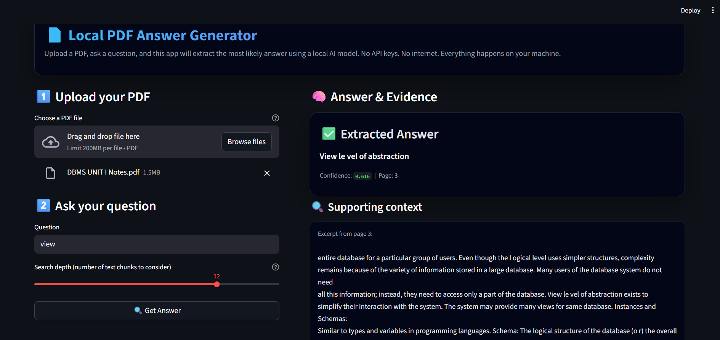

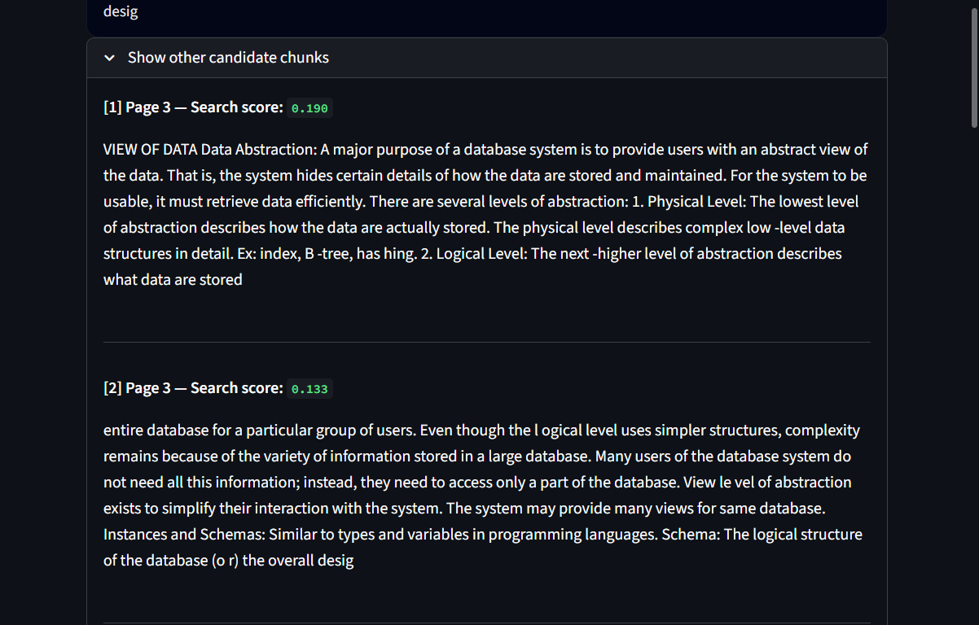

CONCLUSION
The PDF Question-Answering system presents a robust, modular, and scalable architecture that transforms raw documents into reliable, context-grounded answers. By separating concerns across ingestion, preprocessing, embedding generation, retrieval, and LLM reasoning, the system ensures efficiency, traceability, and maintainability. Each component can be independently improved or replaced, enabling long-term extensibility as models and infrastructure evolve.
Through the combination of a vector retrieval pipeline, structured context assembly, and controlled LLM generation, the system delivers accurate responses supported by verifiable citations. Integrated safeguards—including authentication, encryption, monitoring, and retention policies—ensure that the platform remains secure, trustworthy, and suitable for sensitive or enterprise-level workloads.
Overall, this architecture provides a strong foundation for building high-quality document intelligence applications. It is flexible enough for research and prototyping, yet powerful and scalable enough to support production deployments that demand reliability, low latency, and strong privacy guarantees.

